**Project Development Phase**

**Model Performance Test**

|  |  |
| --- | --- |
| Date | 10 November 2022 |
| Team ID | PNT2022TMID06357 |
| Project Name | Project – Detecting of Parkinson’s disease using Machine Learning |
| Maximum Marks | 10 Marks |

**Model Performance Testing:**

Project team shall fill the following information in model performance testing template.

|  |  |  |
| --- | --- | --- |
| **S. .No** | **Parameter** | **Values** |
| 1. | Metrics | Classification Model: Confusion Matrix and Accuracy Score |
| 2. | Testing | Testing model:  Total Requests per second, Response Times, No. of users |
| 3. | Locus Testing Report | **Testing Report:**  **Request Statistics, Response Time Statistics, Final Ratio** |

**1)Metric**

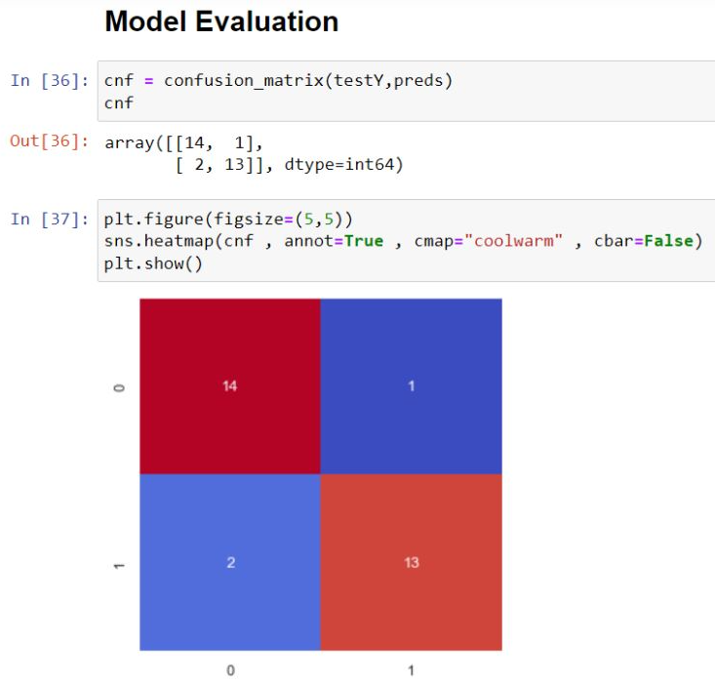

**Accuracy:**

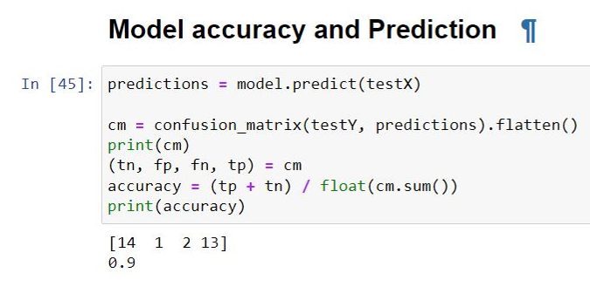

**2) Testing**

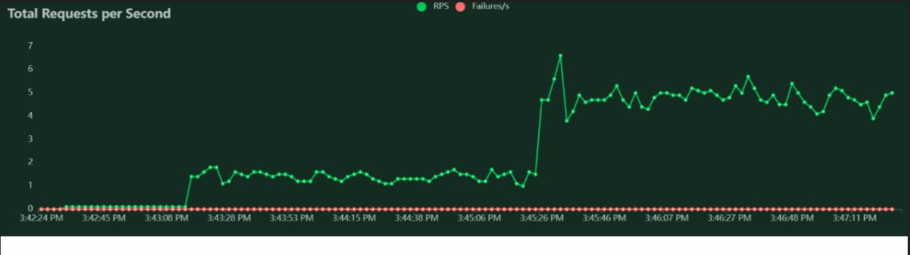

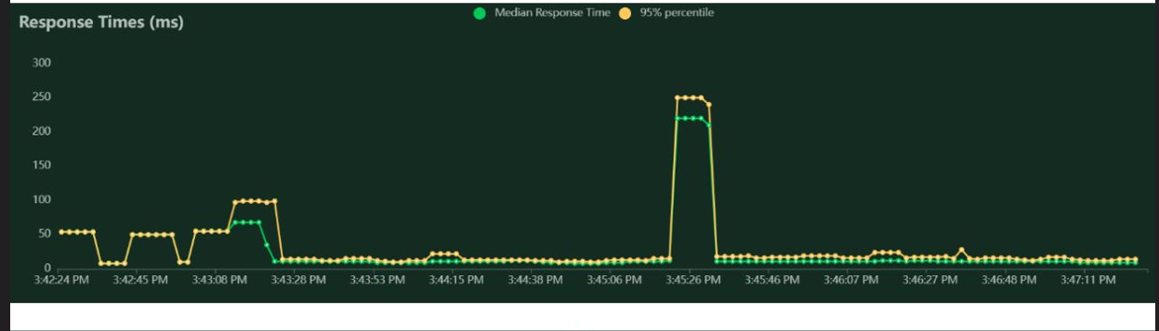

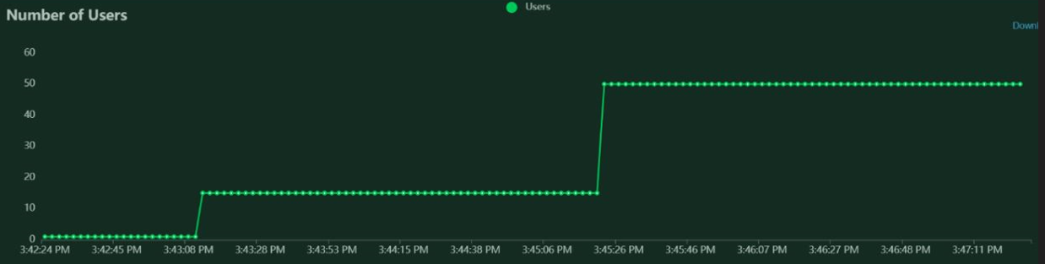

**3) Locus Testing Report:**

